# 2020 DDJ-SX2/SZ/SRT v6.7.0 - mapping for Traktor Pro 3+2 - DJ Estrela

# 2020 DDJ-1000 v6.8.0 - BOME mapping for Traktor Pro 3+2 with Screens - DJ Estrela

**IMPORTANT: v6.7.0 is BETA because of the BOME migration. Please test well before using this mapping live.**

**TO DOWNLOAD:** you can ONLY download if you register and verify your email in the DJTT site!   
**IF IT STILL FAILS:** try again later; the site is often in maintenance.  
  
**ABOUT BOME:** BOME can be tested for free. If you don’t the latest features, download version v6.1.7 instead.

LINKS:

* **Download Link**: <https://maps.djtechtools.com/mappings/9222>
* **Features demo (video)**: <http://youtu.be/H_TE2mtuM6Q>
* **Installation guide (video)**: <https://youtu.be/MbGP_ECnWiQ>
* **Manuals / FAQ:** <https://bit.ly/3cYiBak>

LINKS:

* **Download Link**: [https://maps.djtechtools.com/mappings/9279](https://maps.djtechtools.com/mappings/9278)
* **Features demo (video)**: <https://www.youtube.com/watch?v=NmO9673pHo0&>
* **installation guide (video):** <https://youtu.be/MbGP_ECnWiQ>
* **Manuals / FAQ:** <https://bit.ly/3cYiBak>

FEATURE LIST:

* 7x Jogwheel FX chains
* 5x TP3 MixerFX
* 11x MacroFX
* 21x padFX (“instant gratification”)
* 4x Rolls modes
* Slicer
* Dedicated preview player
* Reverse Flux
* Vinyl Stop
* Beatjump controls
* All functions reachable without shifts

FEATURE LIST:

* Jog Screens
* 7x Jogwheel FX chains
* 5x MixerFX
* 11x MacroFX
* 21x padFX (“instant gratification”)
* 3x tone play modes (“keyboard mode”)
* 8x Rolls
* Slicer
* Dedicated preview player
* Manual adjust of Loops (via jogs)
* Beatjump and Loops pages
* Reverse Flux / Vinyl Stop
* End of track warning blinks / other CDJ emulation features
* All functions reachable without shifts
* Turntable FX, Vinyl Stop

COMPATIBILITY:

* **DDJ-SZ:** As good as it gets. This is where the main mapping was developed.
* **DDJ-SX2:** As good as it gets. This is where the main mapping was developed.
* **DDJ-1000SRT**: Please see the specific documentation and TSI for the 1000SRT in a subfolder. The SRT runs in external mode, so you have **all** Pioneer effects per channel. Jog Screens are not MIDI mappable at the moment.
* **DDJ-SZ2/RZX:** Main mapping wastested in a shop, and it was pretty good.
* **DDJ-SX3/SR/RR/RX:** Pretty good coverage, but not perfect. The zip file has a specific TSI for the DDJ-SR.
* **DDJ-1000**: see [https://maps.djtechtools.com/mappings/9279](https://maps.djtechtools.com/mappings/9278)
* **Traktor Pro 2:** This mapping works perfectly in both Traktor Pro 3 and Traktor Pro 2.

COMPATIBILITY:

* **DDJ-1000:** As good as it gets. This is where the mapping was developed.
* **DDJ-800**:Pretty good, but not perfect. The screens do work yet. The zip has a dedicated TSI for the 800.
* **DDJ-1000SRT**:see <https://maps.djtechtools.com/mappings/9222>
* **Traktor Pro 2:** This mapping works perfectly in both Traktor Pro 3 and Traktor Pro 2.

INSTALLATION:

* **Installation video:** <https://youtu.be/MbGP_ECnWiQ>
* **Installation pictures:** TBD
* See the installation folder for installation pdf guides.
* Tip: Do NOT configure the DDJ device in Traktor! use “Bome Virtual Midi 1” instead. Also load the TSI twice to avoid the FX list bug.

ABOUT THIS MAPPING:

* This an updated 2020 mapping for the Pioneer DDJ family of controllers. It works on both Traktor 3 and 2. It requires the 3rd-party BOME Pro MIDI translator. Free trial versions are available to test everything.
* The mapping was tested **extensively** in both the **DDJ-SX2** and **DDJ-SZ**. Other DDJs are supported as well (please see below).
* It is also the most complete by far. It supports TP3 MixerFX, MacroFX, JogFX chains, padFX, Keyboard mode, Rolls, Slip reverse, and a Preview Player. Be sure to see the documentation for all the features.
* Issues? First, see the installation video and read the extensive documentation; then do not hesitate reporting ANY problems. Do NOT just press thumbs down without any steps to reproduce your issue. Thank you.
* All my mappings are a free gift to the community, to enable DJs to use their preferred Software with their preferred Hardware. If you want further appreciation, PayPal / Patreon donations are welcome ([pedro.estrela@gmail.com](mailto:pedro.estrela@gmail.com) / <https://www.patreon.com/djestrela>)

ABOUT THIS MAPPING:

* This is the only mapping for the DDJ-1000 that supports Jog Screens. It works on both Traktor 3 and 2. It requires the 3rd-party BOME Pro MIDI translator. Free trial versions are available to test everything.
* It is also the most complete by far. It supports TP3 MixerFX, MacroFX, JogFX chains, padFX, Keyboard mode, Rolls, and a Preview Player. Latest features are CDJ-emulation, Loops adjust and Beatjump shortcuts.
* All pad modes are reachable with only two clicks without any shifts. Pressing the “mode” button will conveniently cycle the top-2 pages of that mode.
* Issues? First, First, see the installation video and read the extensive documentation; then do not hesitate reporting ANY problems. Do NOT just press thumbs down without any steps to reproduce your issue. Thank you.
* All my mappings are a free gift to the community, to enable DJs to use their preferred Software with their preferred Hardware. If you want further appreciation, PayPal / Patreon donations are welcome ([pedro.estrela@gmail.com](mailto:pedro.estrela@gmail.com) / <https://www.patreon.com/djestrela>)

BOME mappings installation: <https://youtu.be/MbGP_ECnWiQ>

* 00:00 Introduction
* 00:27 How to download the mappings
* 01:50 Zip file contents, Documentation overview
* 03:45 Step #0: confirm Rekordbox Performance mode
* 04:25 Step #1: How to install BOME trial
* 07:00 Step #2: How to install the BOME-side mapping
* 09:00 Step #3: VERIFY the BOME-side mapping
* 10:40 Step #4: How to install the Traktor-side mapping
* 13:50 Step #5: VERIFY the Trakor-side mapping
* 18:36 Tips (if it still doesn't work)

v6.7.0 merged mapping: <https://youtu.be/5IJZPhHQnc4>

* 0:00 mapping was merged with DDJ-1000 Bome mapping
* 0:40 All pads have been moved to the front
* 2:50 Beatjump, Loops, Layouts
* 4:36 Preview Player (routed to deck 4 on DDJ-SZ)
* 6:30 BOME and the merged mappings
* 7:20 Next version: Turntable FX, Automatic tempo range

V6.1.1 1000SRT Quick Demo: <https://youtu.be/aU3QnOez56A>

* 0:08 External mode = All Pioneer SoundColorFX and BeatFX per channel
* 0:40 All mapping pads modes work fine (Hotcues, Rolls, MacroFx, MixerFX, JogFX)
* 2:37 dedicated beatjump buttons
* 2:55 MIDI scrraching quality
* 3:20 Jog Screens are not MIDI mappable at the moment

V6.1.0 Features / Demo: (update): <https://youtu.be/sanF35CYeSg>

* 00:38 TP3 reverse slip modec
* 01:00 TP3 mixerFX TP3: Filter / Flanger / Time Gater / Noise / Crush
* 02:30 TP3 how to change the 4x mixerFX in preferences
* 03:17 TP2 macroFX: Wormhole / polarwind / flighttest / laserslicer
* 04:00 TP2 FX: delay T3 / flanger / reverb (controlled on sampler volume)
* 05:10 a 3rd MFX page has all the other macroFX
* 06:00 Jog FX demo

V6.0.0 Features / Demo: (first release): <http://youtu.be/H_TE2mtuM6Q>

* 2:10 MacroFX usage (similar to Pioneer ColorFX): Wormhole, Polarwind, Flighttest, LaserSlicer
* 3:45 How to use both Traktor MacroFx and Pioneer ColorFX
* 4:07 Pioneer-style Beat FX, controlled on the lower right corner of the mixer: Echo, Flanger, Reverb
* 5:27 Sub-pages to access all MacroFX
* 7:07 Jogwhell_FX usage demo (seven different chains of 3x effects - very powerful)
* 2:10 MacroFX usage (similar to Pioneer ColorFX): Wormhole, Polarwind, Flighttest, LaserSlicer
* 3:45 How to use both Traktor MacroFx and Pioneer ColorFX
* 4:07 Pioneer-style Beat FX, controlled on the lower right corner of the mixer: Echo, Flanger, Reverb
* 5:27 Sub-pages to access all MacroFX
* 7:07 Jogwhell_FX usage demo (seven different chains of 3x effects - very powerful) [*]
* 9:09 Pressing hotcue now cancels JogwheelFX back into scratch mode
* 9:43 Roll demo [*]
* 10:00 PadFX with 3x subpages [*]
* 10:48 Slicer demo [*]
* 11:05 Second "shift" button (pressing deck number itself)
* 11:50 Waveform zoom +- and Zoom default [*]
* 12:20 Autoloop is always 4x beats - this avoids mistakes!
* 13:20 Beatjump now uses the second shift button
* 15:20 Correcting a wrong loop for just 1x beat
* 17:00 Moving a 4-beat loop for 16x beats
* 18:00 The Sync button now operates like Hotcue. This is useful for TempoSync operation
* 19:40 Key adjustment is now disabled
* 00:00 Tempo range now goes in smll steps (6% / 10% / 16% / 100%) (not shown on video)
* 00:00 shift+tempo = forces changing tempo, ignoring sync value (not shown on video)

BOME mappings installation: <https://youtu.be/MbGP_ECnWiQ>

* 00:00 Introduction
* 00:27 How to download the mappings
* 01:50 Zip file contents, Documentation overview
* 03:45 Step #0: confirm Rekordbox Performance mode
* 04:25 Step #1: How to install BOME trial
* 07:00 Step #2: How to install the BOME-side mapping
* 09:00 Step #3: VERIFY the BOME-side mapping
* 10:40 Step #4: How to install the Traktor-side mapping
* 13:50 Step #5: VERIFY the Trakor-side mapping
* 18:36 Tips (if it still doesn't work)

v6.8.0 DEMO the "super-knob-edition":

* TBD

v6.6.0 DEMO the "CDJ-edition": <https://youtu.be/NmO9673pHo0>

* 0:50 Overview of the new functions
* 1:45 Jog screens bug fixes
* 3:00 CDJ-like loops
* 5:20 Beatjump / loop move
* 6:15 Tone play 3x modes
* 8:10 Beatjump / loop mode pages
* 9:14 Configurable beatsync
* 11:14 Jog ring features

v6.5.0 DEMO Jog Screens using BOME: <https://youtu.be/h9tQZEHr8hk>

* 0:35 Needle position, BPM, Tempo percentage, Time elapsed/Remain, Key Variation
* 1:45 Loop/Beatjump sizes are displayed on the main display
* 2:25 Shift layers shows Base BPM, Tempo range, Loop sizes and Beatjump Sizes
* 4:00 Scratching quality was improved; shift+vinyl disables scratching
* 4:47 shift+quantize resets the jog screens
* 6:04 Quick demo of the previous features: JogFX, Rolls, PadFx, MixerFX, MacroFx
* 8:08 Pioneer BeatFX are in MST channel; TK effects are in channel 1..4

v6.3.3 DEMO Update: <https://www.youtube.com/watch?v=2QKGQ_JUNXo>

* 0:15 JogRing now shows the active deck; Blinks in jogfx mode
* 1:25 Backspins are now possible
* 1:35 Sync is now "toggle"
* 1:50 Fixes to cue monitor
* 3:00 Putting the screens to work
* 3:50 Files on the archive (including installation help)
* 4:50 USER REQUEST: traktor effects list suggestions

v6.3.0 DEMO / FEATURES: <https://www.youtube.com/watch?v=EkSJ9Ug9Zuk>

* 0:30 5-minute overview of the most important features (Jogfx, MixerFx, Loops, Shift2, PreviewPlayer, ...)
* 5:50 The most-used pad modes are now accessible without any shifts (padFX, MacroFx, JogFX). Pressing "mode" twice cycles 2x top pages; pressing "left" cycles all 4x pages
* 8:40 Only the secondary pad modes now requires shift (keyboard, slicer, remix decks)
* 9:15 Memory button = second shift button
* 10:10 Vinyl long stop / vinyl break
* 10:30 Browser: preview player / browser / waveform zoom
* 11:50 Loops / BeatJump
* 15:00 How to correct loops by +1 beat
* 15:40 Beatgrid slide / adjust / lock analysis
* 17:30 TP3 mixer FX: flanger / time gater / crush / noise
* 18:41 How to change mixerfx list in preferences
* 19:30 MacroFX page1: wormhole, polarwind, flighttest, laserslicer
* 20:30 BeatFX shortcuts: T3 delay / flanger / reverb
* 20:51 MacroFX page2 (seven more macroFX)
* 21:20 Manual FX (non-automated). Use MST for pioneer effects!
* 23:00 Mobius FXs (=forever rising)
* 23:50 CAUTION: beware that USB selector does NOT stop USB mixer
* 24:35 JogFX in detail (combo of 3x FX on the jogwheels)
* 26:40 MacroFX in detail
* 27:20 PadFX in detail: quantized roll / Non-quantize roll / 3x padFX pages
* 29:30 Keyboard mode
* 30:30 Slicer mode
* 31:30 Slip reverse / reverse
* 31:40 2-deck and 4-deck automatic layout

DOCUMENTATION IN THE ZIP FILE:

* **Quick overview**: [21x slides](https://github.com/pestrela/music_scripts/blob/master/traktor/mapping_ddj_1000/DDJ-1000%20-%20Quick%20overview.pdf)
* **Installation guide**: [30x slides](https://github.com/pestrela/music_scripts/blob/master/traktor/mapping_ddj_1000/Installation%20Help/DDJ-1000%20-%20Installation%20Guide.pdf)
* **FAQ**: [4x pages](https://github.com/pestrela/music_scripts/blob/master/traktor/mapping_ddj_1000/Installation%20Help/DDJ-1000%20-%20Frequently%20Asked%20Questions.pdf)
* **Detailed manual**: [16x pages](https://github.com/pestrela/music_scripts/blob/master/traktor/mapping_ddj_1000/DDJ-1000%20-%20Detailed%20manual.pdf)
* **Demo Videos**: [between 5..30 minutes](https://www.youtube.com/playlist?list=PLIlvTGzSxI0XHlFyINdT6P42noqvkPISD)

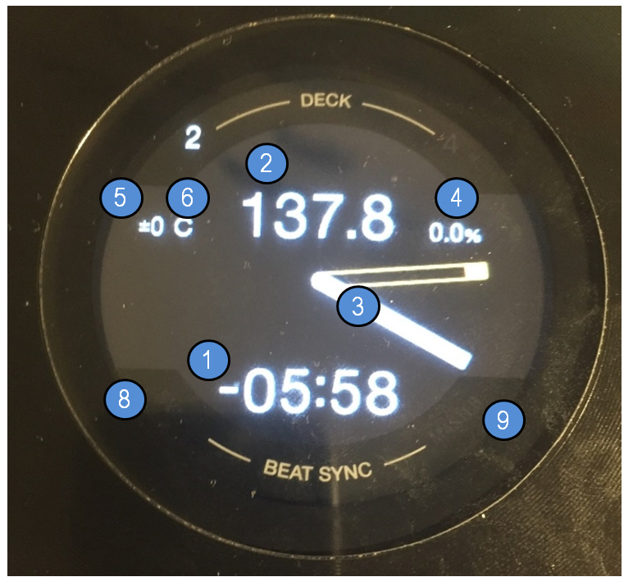

|  |  |  |  |  |
| --- | --- | --- | --- | --- |
|  |  | Section JOG DISPLAYS |  |  |
| # | DDJ-1000 | Main Function | +Shift | +Memory Shift |
|  | BUTTON: LOOPS | Show Loop / Move size (for 2s) | *Move size* | *BeatJump* |
|  | BUTTON: MASTER TEMPO | *KeyLock Toggle* | *Tempo Range (6/10/16/100)* | Toggle Elapsed/Remain |
|  | BUTTON: QUANTIZE |  | RESET SCREENS |  |
|  | BUTTON: SLIP |  | Vinyl On/Off |  |
|  |  |  |  |  |
| 1 | DISPLAY: TIME | Time Elapsed / Remain | Loop Size / Move size |  |
| 2 | DISPLAY: BPM | Current BPM | Original BPM |  |
| 3 | DISPLAY: NEEDLE | Current Position |  |  |
| 4 | DISPLAY: PERCENTAGE | BPM Percentage | Tempo Range |  |
|  |  |  |  |  |
| 5 | DISPLAY: KEY VALUE | *Not Available yet* |  |  |
| 6 | DISPLAY: KEY VARIATION | Key Variation |  |  |
|  |  |  |  |  |
| 7 | JOG RING LED | On-Air Deck / JogFX enabled |  |  |
| 8 | DISPLAY: SYNC | Sync |  |  |
| 9 | DISPLAY: MASTER | Master |  |  |

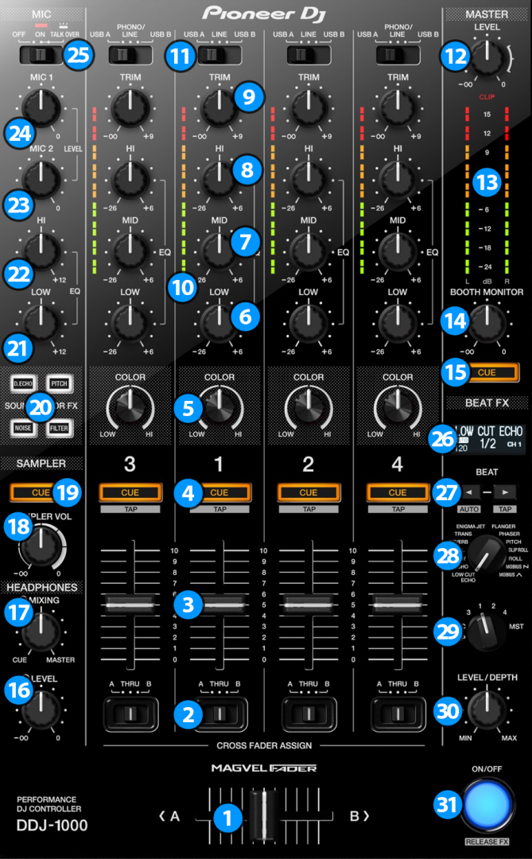

|  |  |  |  |
| --- | --- | --- | --- |
|  |  | Section MIXER |  |
|  | DDJ-1000 | Main Function | +Shift |
| 1 | CROSSFADER | Crossfader | Crossfader Curve |
| 2 | CROSS FADER ASSIGN | CrossFader Assign |  |
| 3 | CHANNEL FADER | Channel Fader | CH Fader Start |
| 4 | CUE MONITORING | Cue Monitor | Echo Out Type (1/2/3/4) |
|  | *Note: use "+memory+shift" on cue 1 to toggle between Internal and external Cues* |  |  |
|  |  |  |  |
| 5 | FILTER (KNOB) | MixerFX / MacroFX |  |
| 6 | LOW | Low |  |
| 7 | MID | Mid |  |
| 8 | HI | Hi |  |
| 9 | TRIM | Gain |  |
| 10 | FADER VU | Pre-fader Level |  |
|  |  |  |  |
| 11 | INPUT SELECT | Input select |  |
| 12 | MASTER LEVEL | Volume Master Out |  |
| 13 | MASTER VUMETER | Master Level |  |
| 14 | BOOTH LEVEL | Volume Booth Out |  |
| 15 | MASTER CUE | MASTER CUE |  |
|  |  |  |  |
| 16 | HEADPHONES VOLUME | *(hardware operation)* |  |
| 17 | HEADPHONES MIXING | *(hardware operation)* |  |
| 18 | SAMPLER VOLUME | Macro FX Wet |  |
| 19 | SAMPLER CUE | *(hardware operation)* |  |
|  |  |  |  |
| 20 | DUB ECHO | MixerFX: Flanger | MixerFX: Noise |
| 20 | PITCH | MixerFX: TimeGater |  |
| 20 | NOISE | MixerFX: Crush |  |
| 20 | FILTER | Filter |  |
|  |  |  |  |
| 21 | MIC LOW EQ | *(hardware operation)* |  |
| 22 | MIC HI EQ | *(hardware operation)* |  |
| 23 | MIC 2 VOLUME | *(hardware operation)* |  |
| 24 | MIC 1 VOLUME | *(hardware operation)* |  |
| 25 | MIC CONTROL | *(hardware operation)* |  |

|  |  |  |  |
| --- | --- | --- | --- |
|  |  | section BEAT FX |  |
|  | DDJ-1000 | Main Function | +Shift |
| 26 | BEATFX SCREEN |  |  |
| 27 | BEAT < | Parameter #3 left |  |
| 27 | BEAT > | Parameter #3 Right |  |
|  |  |  |  |
| 28 | LOW CUT | Delay T3 |  |
| 28 | ECHO | Delay |  |
| 28 | MT DELAY | Ramp Delay |  |
| 28 | SPIRAL | Auto Bouncer |  |
| 28 | REVERB | Reverb T3 |  |
| 28 | TRANS | Gater |  |
| 28 | ENIGMA JET |  |  |
| 28 | FLANGER | Flanger |  |
| 28 | PHASER | Phaser |  |
| 28 | PITCH | Reverse Grain |  |
| 28 | SLIP ROLL | BeatSlicer |  |
| 28 | ROLL | BeatMasher 2 |  |
| 28 | MOBIUS SAW |  |  |
| 28 | MOBIUS TRI |  |  |
|  |  |  |  |
| 29 | SELECT 1/2/3/4 | Select FX4 |  |
|  |  | note: Use MST for Pioneer FX |  |
| 30 | LEVEL/DEPTH | Dry/Wet FX4 |  |
| 31 | ON/OFF | On/OFF FX3 | Vinyl Break (Release FX) |

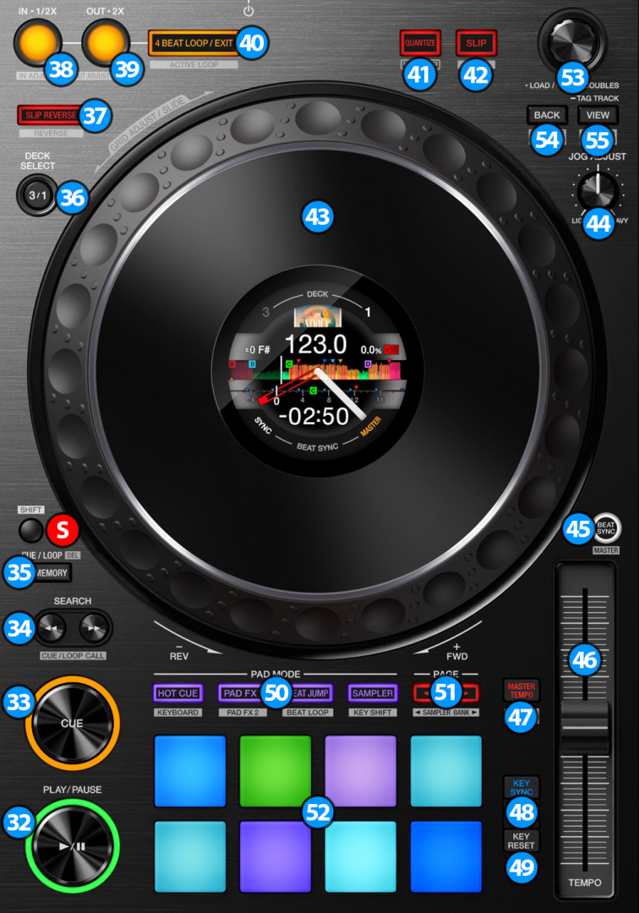

|  |  |  |  |  |
| --- | --- | --- | --- | --- |
|  |  | Section DECK |  |  |
| # | DDJ-1000 | Main Function | +Shift | +Memory Shift |
| S | **SHIFT** | Main Shift |  |  |
| 35 | **MEMORY** | Second Shift |  |  |
|  |  |  |  |  |
| 32 | PLAY | Play/Pause | Vinyl Stop |  |
| 33 | CUE | Cue | Track Begin |  |
| 34 | SEARCH << | Size Move Half | move left (beat / loop jump) | move -1 beat |
| 34 | SEARCH >> | Size Move Double | move right (beat / loop jump ) | move +1 beat |
| 36 | DECK SELECT (1/2/3/4) | Select Deck 1-4 | Deck Flavor |  |
| 37 | SLIP REVERSE | TP3 Reverse Flux | TP3 Reverse |  |
|  |  |  |  |  |
| 38 | IN | Loop IN / Half loop / Exit edit | Edit IN point (+mem: whole loop) | Size Loop Half |
| 39 | OUT | Loop OUT / Half loop / Exit edit | Edit OUT point | Size Loop Double |
| 40 | 4 BEAT LOOP | 4-Beat loop / Exit loop / Exit edit | Activate Loop | Size loop activate |
| 41 | QUANTIZE / WAKE UP | Quantize + Snap Toggle | Reset mapping |  |
| 42 | SLIP / VINYL | Flux Mode On/Off | Scratch On/Off |  |
|  |  |  |  |  |
| 43 | JOG (platter ) | Scratch / Pitch Bend | Quick Search |  |
| 43 | JOG (wheel side) | Pitch Bend |  |  |
| 44 | JOG ADJUST | Jog Sensitivity (hardware) |  |  |
|  |  |  |  |  |
| 45 | BEAT SYNC (Traktor mode) | Toggle Sync | Set as tempo Master | Sync Off |
| 45 | BEAT SYNC (Serato mode) | Phase Reset | Set as tempo Master | Sync Off |
| 45 | BEAT SYNC (toggle mode) | *Note: use "+memory+shift" to toggle between Traktor and Serato sync modes* |  |  |
| 46 | TEMPO | Tempo Control | Tempo Control (No sync) |  |
|  |  |  |  |  |
| 47 | MASTER TEMPO | KeyLock Toggle | Tempo Range (6/10/16/100) | Time Elapsed / Remain |
| 48 | KEY SYNC | *(see grid section)* | *(see grid section)* |  |
| 49 | KEY RESET | *(see grid section)* | *(see grid section)* |  |
|  |  |  |  |  |
| 50 | PAD MODES | Change Mode 1..4; Twice=cycle page | Change Mode 5..8; Twice=cycle |  |
| 51 | PAD PAGE LEFT | Cycle pad Pages |  |  |
| 51 | PAD PAGE RIGHT | Direct select pad pages |  |  |
| 52 | PADS | *(see detailed section)* | *(see detailed section)* |  |
| 53 | TURN BROWSER | Scroll List | Scroll Tree | WaveForm Zoom Adjust |
| 53 | PUSH BROWSER | Load Track | Open / close Folder | WaveForm Zoom Auto |
| 54 | BACK | Preview Player (Hold) | Scroll Favorites |  |
| 55 | VIEW | Browser Only (Toggle) | Goto Collection |  |

|  |  |  |  |  |
| --- | --- | --- | --- | --- |
|  |  | Section BEATGRID |  |  |
|  | DDJ-1000 | + KEY SYNC | + KEY RESET | +Shift |
| 48 | KEY SYNC |  |  | Set Grid Marker |
| 49 | KEY RESET |  |  | Delete Grid Marker |
|  | KEY SYNC+KEY RESET | Track ON/OFF LOCK | Auto Grid Marker |  |
|  |  |  |  |  |
| 43 | Turn Jog Wheel | Move Grid | BPM +/- |  |
| 53 | Turn BROWSER | Move Grid [ FINE ] | BPM +/- [ FINE ] |  |
| 53 | Push BROWSER | SLIDE AUTO | BPM AUTO |  |

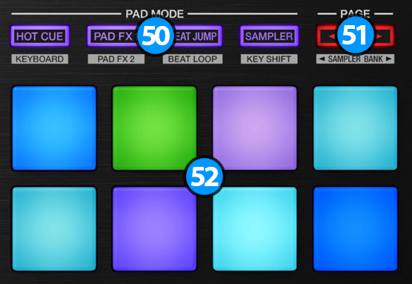

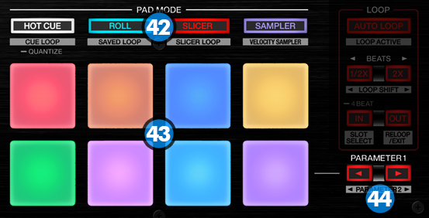

|  |  |  |  |
| --- | --- | --- | --- |
|  |  | mode #1: HOTCUE |  |
|  | DDJ-1000 | Main Function | +Shift |
|  | PAD 1 | Hotcue 1 | Delete Hotcue |
|  | PAD 2 | Hotcue 2 | Delete Hotcue |
|  | PAD 3 | Hotcue 3 | Delete Hotcue |
|  | PAD 4 | Hotcue 4 | Delete Hotcue |
|  | PAD 5 | Hotcue 5 | Delete Hotcue |
|  | PAD 6 | Hotcue 6 | Delete Hotcue |
|  | PAD 7 | Hotcue 7 | Delete Hotcue |
|  | PAD 8 | Hotcue 8 | Delete Hotcue |
|  | HOTCUE [Long Press] | Quantize |  |
|  | PARAMETER < |  | PITCH -0,01 |
|  | PARAMETER > |  | PITCH +0,01 |

|  |  |  |  |
| --- | --- | --- | --- |
|  |  | mode #2: PADFX / ROLL |  |
|  | DDJ-1000 | Main Function | +Shift |
|  | PAD 1 | Gater #1 | PAD FX page 1 |
|  | PAD 2 | Gater #2 | PAD FX page 2 |
|  | PAD 3 | Gater #3 | PAD FX page 3 |
|  | PAD 4 | Peak Filter | ROLL |
|  | PAD 5 | Beatmasher #1 |  |
|  | PAD 6 | Beatmasher #2 |  |
|  | PAD 7 | Zzzurp |  |
|  | PAD 8 | Release FX (toggle) |  |
|  |  |  |  |
|  | PAD 1 | Delay #1 | PAD FX page 1 |
|  | PAD 2 | Delay #2 | PAD FX page 2 |
|  | PAD 3 | Delay / BeatSlicer | PAD FX page 3 |
|  | PAD 4 | Flanger Flux | ROLL |
|  | PAD 5 | DigitalLofi / BeatSlicer #1 |  |
|  | PAD 6 | DigitalLofi / BeatSlicer #2 |  |
|  | PAD 7 | BeatSlicer |  |
|  | PAD 8 | Release FX (toggle) |  |
|  |  |  |  |
|  | PAD 1 | Filter Pulse | PAD FX page 1 |
|  | PAD 2 | LaserSlicer | PAD FX page 2 |
|  | PAD 3 | Bass-O-Matic #1 | PAD FX page 3 |
|  | PAD 4 | Bass-O-Matic #2 | ROLL |
|  | PAD 5 | Bouncer / EventHorizon |  |
|  | PAD 6 | Bouncer |  |
|  | PAD 7 | EventHorizon |  |
|  | PAD 8 | Release FX (toggle) |  |
|  |  |  |  |
|  | PAD 1 | Roll ‘’1/8 (quantize) | PAD FX page 1 |
|  | PAD 2 | Roll ‘’1/4 (quantize) | PAD FX page 2 |
|  | PAD 3 | Roll ‘’1/2 (quantize) | PAD FX page 3 |
|  | PAD 4 | Roll ‘’1 (quantize) | ROLL |
|  | PAD 5 | Roll ‘’1/8 (non-quantize) |  |
|  | PAD 6 | Roll ‘’1/4 (non-quantize) |  |
|  | PAD 7 | Roll ‘’1/2 (non-quantize) |  |
|  | PAD 8 | Roll ‘’1 (non-quantize) |  |
|  |  |  |  |
|  | PARAMETER < | Next PFX page |  |
|  | PARAMETER > | Choose PFX pages |  |

|  |  |  |  |
| --- | --- | --- | --- |
|  |  | mode #3: MACROFX |  |
| / MIXER FX |
|  | DDJ-1000 | Main Function | +Shift |
|  | PAD 1 | MacroFX: WormWhole | MACRO FX page 1 |
|  | PAD 2 | MacroFX: PolarWind | MIXER FX |
|  | PAD 3 | MacroFX: FlightTest | MACRO FX page 2 |
|  | PAD 4 | MacroFX: LaserSlicer |  |
|  | PAD 5 | BeatFX: Delay T3 |  |
|  | PAD 6 | BeatFX: Flanger |  |
|  | PAD 7 | BeatFX: Reverb |  |
|  | PAD 8 | Toggle On/OFF |  |
|  |  |  |  |
|  | PAD 1 | MixerFX: Flanger | MACRO FX page 1 |
|  | PAD 2 | MixerFX: TimeGater | MIXER FX |
|  | PAD 3 | MixerFX: Noise | MACRO FX page 2 |
|  | PAD 4 | MixerFX: Crush |  |
|  | PAD 5 | Filter |  |
|  | PAD 6 |  |  |
|  | PAD 7 |  |  |
|  | PAD 8 | Toggle On/OFF |  |
|  |  |  |  |
|  | PAD 1 | MacroFX: EventHorizon | MACRO FX page 1 |
|  | PAD 2 | MacroFX: Zzzuurp | MIXER FX |
|  | PAD 3 | MacroFX: DarkMatter | MACRO FX page 2 |
|  | PAD 4 | MacroFX: Bass-O-Matic |  |
|  | PAD 5 | MacroFX: Strrretch (Slow) |  |
|  | PAD 6 | MacroFX: Strrretch (Fast) |  |
|  | PAD 7 | MacroFX: GranuPhase |  |
|  | PAD 8 | Toggle On/OFF |  |
|  | PARAMETER < | Next MFX page |  |
|  | PARAMETER > | Choose MFX pages |  |

|  |  |  |  |
| --- | --- | --- | --- |
|  |  | mode #4: JOG FX |  |
|  | DDJ-1000 | Main Function | +Shift |
|  | PAD 1 | Beatmasher / Digital filter / Gater |  |
|  | PAD 2 | Beatmasher / Filter / Reverb |  |
|  | PAD 3 | Eventhorizon / Gater |  |
|  | PAD 4 | Gater / Beatmasher / Reverb |  |
|  | PAD 5 | Flanger / Gater |  |
|  | PAD 6 | Beatmasher / Peak filter / Gater |  |
|  | PAD 7 | FormatFilter / Peak filter / Flightest |  |
|  | PAD 8 | Release FX (toggle) |  |
|  | PARAMETER < |  |  |
|  | PARAMETER > |  |  |

|  |  |  |  |
| --- | --- | --- | --- |
|  |  | mode #5: TONE PLAY |  |
|  | DDJ-1000 | Main Function | +Shift |
|  | PAD 1 | Key +4 | Key +12 |
|  | PAD 2 | Key +5 | Key 0 |
|  | PAD 3 | Key +6 | Key Inc |
|  | PAD 4 | Key +7 | Key Dec |
|  | PAD 5 | Key 0 | Key +8 |
|  | PAD 6 | Key +1 | Key +9 |
|  | PAD 7 | Key +2 | Key +10 |
|  | PAD 8 | Key +3 | Key +11 |
|  |  |  |  |
|  | PARAMETER < | Next PFX page |  |
|  | PARAMETER > | Choose PFX pages |  |

|  |  |  |  |
| --- | --- | --- | --- |
|  |  | mode #6: BEATJUMP / LOOP |  |
|  | DDJ-1000 | Main Function | +Shift |
|  | PAD 1 | Jump -1 | Loop 4 |
|  | PAD 2 | Jump +1 | Loop 2 |
|  | PAD 3 | Jump -4 | Loop 1 |
|  | PAD 4 | Jump +4 | Loop 1/2 |
|  | PAD 5 | Jump -8 | Loop 4 |
|  | PAD 6 | Jump +8 | Loop 8 |
|  | PAD 7 | Jump -16 | Loop 16 |
|  | PAD 8 | Jump +16 | Loop 32 |
|  | PARAMETER < | BeatJump mode |  |
|  | PARAMETER > | Loop mode |  |

|  |  |  |  |
| --- | --- | --- | --- |
|  |  | mode #7: SLICER |  |
|  | DDJ-1000 | Main Function | +Shift |
|  | PAD 1 | Slicer #1 | 8 beats |
|  | PAD 2 | Slicer #2 | 16 beats odd |
|  | PAD 3 | Slicer #3 | 16 beats even |
|  | PAD 4 | Slicer #4 |  |
|  | PAD 5 | Slicer #5 |  |
|  | PAD 6 | Slicer #6 |  |
|  | PAD 7 | Slicer #7 |  |
|  | PAD 8 | Slicer #8 |  |
|  | PARAMETER < |  |  |
|  | PARAMETER > |  |  |

|  |  |  |  |
| --- | --- | --- | --- |
|  |  | mode #8: SAMPLER |  |
|  | DDJ-1000 | Main Function | +Shift |
|  | PAD 1 | Cell #1 / #9 | Column #1 Mute |
|  | PAD 2 | Cell #2 / #10 | Column #2 Mute |
|  | PAD 3 | Cell #3 / #11 | Column #3 Mute |
|  | PAD 4 | Cell #4 / #12 | Column #4 Mute |
|  | PAD 5 | Cell #5 / #13 | Column #1 Loop / 1-shot |
|  | PAD 6 | Cell #6 / #14 | Column #2 Loop / 1-shot |
|  | PAD 7 | Cell #7 / #15 | Column #3 Loop / 1-shot |
|  | PAD 8 | Cell #8 / #16 | Column #4 Loop / 1-shot |
|  | PARAMETER < | Pad 1 to 8 | Page - |
|  | PARAMETER > | Pad 9 to 16 | Page + |

|  |  |  |  |
| --- | --- | --- | --- |
|  |  | Section MIXERFX |  |
|  | DDJ-1000 | Main Function | +Shift |
| 20 | DUB ECHO | MixerFX: Flanger | MixerFX: Noise |
| 20 | PITCH | MixerFX: TimeGater |  |
| 20 | NOISE | MixerFX: Crush |  |
| 20 | FILTER | Filter |  |
|  |  |  |  |
| 5 | FILTER (KNOB) | Macro FX / Mixer FX |  |
| 18 | SAMPLER VOLUME | Macro FX Wet |  |

(note: DDJ-SZ shown, adaptions were made for SX2, SRT and other controllers as needed)

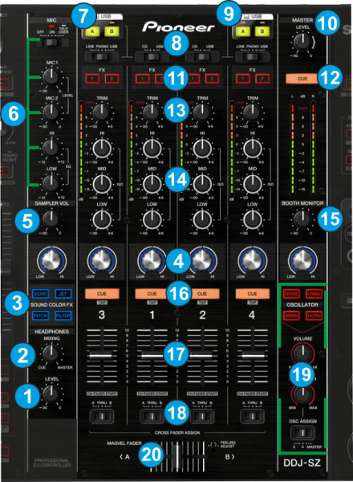

|  |  |  |  |
| --- | --- | --- | --- |
|  |  | Section MIXER |  |
|  | DDJ | Main Function | +Shift |
| 1 | HEADPHONES VOLUME | *(hardware operation)* |  |
| 2 | HEADPHONES MIXING | *(hardware operation)* |  |
|  | *Note: use "+shift2+shift1" on cue 1 to toggle between Internal and external Cues* |  |  |
|  |  |  |  |
| 3 | ColorFX | *(hardware operation)* |  |
| 3 | ColorFX | *(hardware operation)* |  |
| 3 | ColorFX | *(hardware operation)* |  |
| 3 | ColorFX | *(hardware operation)* |  |
| 4 | FILTER (KNOB) | MixerFX / MacroFX |  |
|  |  |  |  |
| 5 | SAMPLER VOLUME | Macro FX Wet |  |
| 6 | MIC CONTROLS | *(hardware operation)* |  |
| 7 | USB A/B | *(hardware operation)* |  |
|  |  |  |  |
| 8 | INPUT SELECT | Input select |  |
| 10 | MASTER LEVEL | Volume Master Out |  |
| 11 | FX SELECT | Manual FX routing |  |
| 12 | MASTER CUE | (Hardware operation) |  |
|  |  |  |  |
| 13 | TRIM | Gain |  |
| 14 | LOW | Low |  |
| 14 | MID | Mid |  |
| 14 | HI | Hi |  |
|  |  |  |  |
| 15 | BOOTH LEVEL | Volume Booth Out |  |
| 16 | CUE MONITORING | Cue Monitor | Echo Out Type (1/2/3/4) |
| 17 | CHANNEL FADER | Channel Fader | CH Fader Start |
| 18 | CROSS FADER ASSIGN | CrossFader Assign |  |
|  |  |  |  |
| 19 | OSC BUTTON | MixerFX (TBD) |  |
| 19 | OSC BUTTON | MixerFX (TBD) |  |
| 19 | OSC BUTTON | MixerFX (TBD) |  |
| 19 | OSC BUTTON | MixerFX (TBD) |  |
| 19 | OSC VOLUME | *Keep this at zero!!* |  |
| 19 | OSC PARAMETER | *Dry/Wet all units* |  |
| 19 | OSC ASSIGN | *Keep this at "4"* |  |
|  |  |  |  |
| 20 | CROSSFADER | Crossfader | Crossfader Curve |

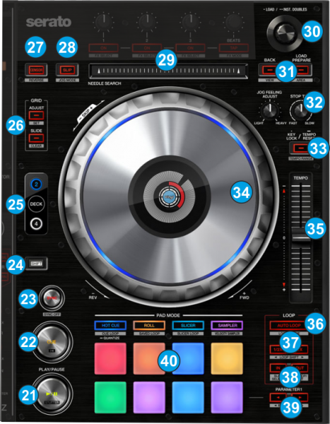

|  |  |  |  |  |
| --- | --- | --- | --- | --- |
|  |  | Section DECK |  |  |
|  | DDJ | Main Function | +Shift1 | +Shift2 |
| 24 | **SHIFT** | Main Shift |  |  |
| 25 | **DECK SELECT** | Second Shift / Deck Select | Deck Flavor |  |
|  |  |  |  |  |
| 21 | PLAY | Play/Pause | Vinyl Stop |  |
| 22 | CUE | Cue | Track Begin |  |
|  |  |  |  |  |
| 23 | BEAT SYNC (Traktor mode) | Toggle Sync | Set as tempo Master | Sync Off |
| 23 | BEAT SYNC (Serato mode) | Phase Reset |
| 23 | BEAT SYNC (Elastic beatgrid) | Phase Reset ; Jog = Sync off |
| 23 | BEAT SYNC *(configuration)* | *Note: use "+memory+shift" to select sync modes* |  |  |
|  |  |  |  |  |
| 26 | GRID ADJUST | *(see grid section)* | *(see grid section)* |  |
| 26 | GRID SLIDE | *(see grid section)* | *(see grid section)* |  |
| 27 | CENSOR | Reverse Flux | Reverse |  |
| 28 | SLIP / VINYL | Flux Mode On/Off | Scratch On/Off |  |
| 29 | NEEDLE SEARCH | Needle Search |  |  |
|  |  |  |  |  |
| 30 | TURN BROWSER | Scroll List | Scroll Tree | WaveForm Zoom Adjust |
| 30 | PUSH BROWSER | Load Track | Open / close Folder | WaveForm Zoom Auto |
| 31 | BACK | Preview Player (Hold) | Scroll Favorites |  |
| 31 | VIEW | Browser Only (Toggle) | Goto Collection |  |
|  |  |  |  |  |
| 32 | JOG ADJUST | Jog Sensitivity (hardware) |  |  |
| 33 | MASTER TEMPO | KeyLock Toggle | Tempo Range (6/10/16/100) | Time Elapsed / Remain |
| 34 | JOG (platter ) | Scratch / Pitch Bend | Quick Search |  |
| 34 | JOG (wheel side) | Pitch Bend |  |  |
|  |  |  |  |  |
| 36 | 4 BEAT LOOP | 4-Beat loop / Exit loop / Exit edit | Activate Loop | Size loop activate |
| 37 | 1/2x | Half loop |  |  |
| 37 | 2x | Double loop |  |  |
| 38 | IN | Loop IN / Half loop / Exit edit | Edit IN point (+mem: whole loop) | Size Loop Half |
| 38 | OUT | Loop OUT / Double loop / Exit edit | Edit OUT point | Size Loop Double |
|  |  |  |  |  |
| 39 | PARAMETER << | move left (beat / loop jump) | Size Move Half | move -1 beat |
| 39 | SEARCH >> | move right (beat / loop jump ) | Size Move Double | move +1 beat |
|  |  |  |  |  |
| 40 | PAD MODES | Change Mode 1..4; Twice=cycle page | Change Mode 5..8; Twice=cycle |  |
| 40 | QUANTIZE (long press) | Quantize + Snap Toggle | Reset mapping |  |
| 40 | PADS | *(see detailed section)* | *(see detailed section)* |  |

|  |  |  |  |  |
| --- | --- | --- | --- | --- |
|  |  | Section BEATGRID |  |  |
|  | DDJ | + GRID ADJUST | + GRID SLIDE | +Shift |
| 26 | GRID ADJUST |  |  | Set Grid Marker |
| 26 | GRID SLIDE |  |  | Delete Grid Marker |
| 26 | GRID ADJUST+SLIDE | Lock Track ON/OFF | Auto Grid Marker |  |
|  |  |  |  |  |
| 34 | Turn Jog Wheel | Move Grid | BPM +/- |  |
| 30 | Turn BROWSER | Move Grid [ FINE ] | BPM +/- [ FINE ] |  |
| 30 | Push BROWSER | SLIDE AUTO | BPM AUTO |  |

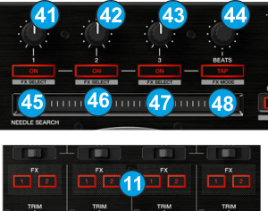

|  |  |  |  |
| --- | --- | --- | --- |
|  |  | Section MANUAL FX |  |
|  | DDJ | Main Function | +Shift1 |
| 41 | FX1 KNOB | Knob FX1 |  |
| 42 | FX2 KNOB | Knob FX2 |  |
| 43 | FX3 KNOB | Knob FX3 |  |
| 44 | BEATS (rotate) | Dry/Wet | Traktor Master Volume |
| 44 | BEATS (press) | Toggle all FX units | Record |
|  |  |  |  |
| 45 | FX1 BUTTON | FX1 ON | Select FX1 |
| 46 | FX2 BUTTON | FX2 ON | Select FX1 |
| 47 | FX3 BUTTON | FX3 ON | Select FX1 |
| 48 | TAP | Turn All FX Off |  |